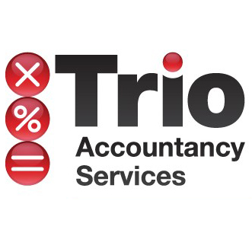

AUTUMN STATEMENT: FOR IMMEDIATE RELEASE

25th November 2015

GLOUCESTERSHIRE BASED ACCOUNTANTS REACTION TO THE AUTUMN STATEMENT & SPENDING REVIEW

Expect Slow Down in Buy To Let Property Market & Digital Tax System
Will Cause Burden For SMEs

Following today’s Autumn Statement and Spending Review, Trio Accountancy Services, a Gloucestershire-based professional tax and accountancy firm, issued its reaction to the Chancellor’s proposed changes.
Mark Faherty, Tax Manager of Trio Accountancy Services, explains:

The 3% increase in SDLT for 2nd homes and buy-to-let – NEUTRAL
“Whilst this may, on the face of it, appear to be an additional burden on the investor in expanding a property portfolio, we believe the market is likely to react accordingly and in our opinion this is also unlikely to have any significant effect on rent levels for the same reason. Overall I expect this to be fairly neutral for investors and tenants but may have a drag on property price increases and additional bargaining ammunition for “normal” buyers. As a result, this may cause a slow-down in the buy to let market”.

“The reduction of the stamp duty filing and payment date may cause administrative issues to start with but, with technology improvements, should prove relatively easy to adapt to”.

The shortening of the CGT payment window for residential property sales can be both a benefit and a disadvantage. POSITIVE AND NEGATIVE
“It will enable the seller to settle early out of the proceeds; we have yet to see whether this will form part of the solicitor’s responsibility, like stamp duty. In the current system I have seen occasions where the seller has not got the funds to pay the tax when the payment date arrives which can be as much as 21 months later. The disadvantage is that these funds will no longer be available to invest, either on deposit or in other ventures”.

The new digital tax system will be a significant burden on small businesses and landlords, particularly those who are not VAT registered, as they will need to maintain their business records on a regular and accurate basis. WARNING
“At present the accountant is provided with the business records once a year and there is up to 10 months (and in some cases up to 21 months) to submit the return to HMRC. It is now proposed that this will have to be done at least every three months and in some cases monthly and, possibly, within the current VAT return deadlines; one month and 7 days after the end of the period. It is also likely that other income unknown to HMRC, such as dividends received, private interest, foreign income and capital gains will have to be included.”

--ENDS--

For further information, please contact:
Mark Faherty, Trio Accountancy 07970 694203/ 01242 584046
Nicola Mitchell, Mitchell Moneypenny nicola@mitchellmoneypenny.com 07980 684240

Notes to Editors:
Trio Accountancy Services are accountants who have been based in Cheltenham since 1980. We offer a wealth of experience in accountancy management for UK and overseas based businesses – both small and large.

Members of the Association of International Accountants and the Chartered Institute of Taxation. The practice is under the directorship of Mervyn Sanderson and Mark Faherty.

